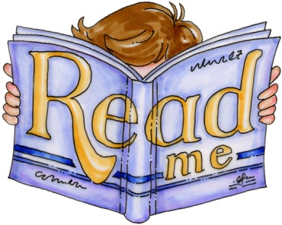
Choosing the Right Book
Choosing a book that is not too easy and not too difficult can be a challenge for a student. In class, we use the AR level of a book to help us determine of the book is an appropriate level. To check a book’s AR level, visit www.arbookfind.com
If there is no AR level available, we use the “5 Finger Rule” to decide if a pleasure reading book is at an appropriate level for a student. Here’s what a student should do:
- Pick a book that looks interesting and open to a page at random.
- Read the page and each time you see a word that you don’t know, put up one finger.
- When you finish reading the page, see how many fingers are raised:
  - 1 finger – Easy reading
  - 2 fingers – Easier, appropriate reading
  - 3 fingers – Appropriate reading
  - 4 fingers – Challenging, appropriate reading
  - 5 or more fingers – Difficult reading
While I recommend that students read books that are at their appropriate reading level, remember that a pleasure-reading book does not necessarily need to be discounted just because it is an easier or a challenging book.
Happy reading!

